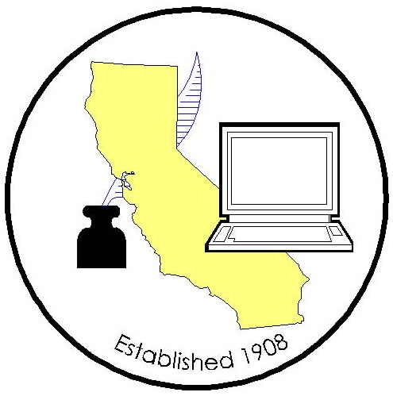

California Association of
Clerks and Election Officials

OFFICERS 2002-2004
ANN REED
PRESIDENT
Shasta County
P.O. Box 990880
Redding, CA 96099
530-225-5166
530-225-5454 fax
areed@co.shasta.ca.us
CONNY B. MCCORMACK
VICE PRESIDENT
Los Angeles County
STEPHEN WEIR
TREASURER
Contra Costa County
KATHLEEN MORAN
SECRETARY
Colusa County

BOARD OF DIRECTORS
APPOINTED:
COLLEEN BAKER
Siskiyou County
DIXIE FOOTE
El Dorado County
TIM JOHNSON
Tuolumne County
ROSALYN LEVER
Orange County
REBECCA MARTINEZ
Madera County
JOHN MCKIBBEN
Los Angeles County
SALLY MCPHERSON
San Diego County
DOLORES PROVENCIO
Imperial County
JULIE RODEWALD
San Luis Obispo County MISCHELLE TOWNSEND
Riverside County
ELECTED:
JULIE BUSTAMANTE
Northern Area
Lassen County
JIM MCCAULEY
Mother Lode Area
Placer County
LINDA TULETT
Bay Area
San Mateo County
SUSAN CONNOR
Central Area
Madera County
STEVE RODERMUND
Southern Area
Orange County

ADVISORY COUNCIL
BRADLEY J. CLARK
Alameda County
MARSHA WHARFF
Mendocino County
KEN PETTIT
Santa Barbara County

LEGISLATIVE COMMITTEES

CLERK OF THE BOARD:
VIOLET VARONA-LUKENS
Los Angeles County
COUNTY CLERK:
EEVE LEWIS
Sonoma County
COURTS:
LARRY JACKSON
Los Angeles County
ELECTIONS:
ERNIE HAWKINS
Sacramento County
BRADLEY J. CLARK
Alameda County

OFFICERS 2006-2008
STEVE WEIR
PRESIDENT
Contra Costa County
524 Main Street
Martinez, CA 94553
(925) 646-2955
sweir@cr.cccounty.us

REBECCA MARTINEZ
VICE PRESIDENT
Madera County
GAIL PELLERIN
TREASURER
Santa Cruz County
CATHY DARLING
SECRETARY
Shasta County

BOARD OF DIRECTORS
APPOINTED:
JANICE ATKINSON
Sonoma County
DARLENE BLOOM
Orange County
CANDACE GRUBBS
Butte County
JOSEPH HOLLAND
Santa Barbara County
NEAL KELLEY
Orange County
DEAN LOGAN
Los Angeles County
JOHN MCKIBBEN
Los Angeles County
KATHIE MORAN
Colusa County
DOLORES PROVENCIO
Imperial County
ELMA ROSAS
Santa Clara County
KAY VINSON*
City Clerk, Murrieta
* non-voting member
ELECTED:
JULIE BUSTAMANTE
Northern Area
Lassen County
BARBARA DUNMORE
Southern Area
Riverside County
CANDY LOPEZ
Bay Area
Contra Costa County
LEE LUNDRIGAN
Central Area
Stanislaus County
JIM MCCAULEY
Mother Lode Area
Placer County

ADVISORY COUNCIL
CONNY MCCORMACK
Los Angeles County
MARSHA WHARFF
Mendocino County

LEGISLATIVE COMMITTEES

CLERK OF THE BOARD:
SACHI A. HAMAI
Los Angeles County
COUNTY CLERK:
KATHIE MORAN
Colusa County
VICKI PETERSEN
Sonoma County
ELECTIONS:
JILL LAVINE
Sacramento County
DEBORAH SEILER
Solano County
Officium Populi – Office of the People

April 23, 2008

The Honorable Ted Gaines
California State Assembly
State Capitol, Room 2002
Sacramento CA 95814

Dear Assembly Member Gaines:

AB 2218 (Gaines) Local government assessment and fee ballots
NEUTRAL

The Clerk of the Board of Supervisors members of the California Association of Clerks and Election Officials (CACEO) are pleased to change their position on AB 2218, as amended April 14, 2008, to NEUTRAL.

We would like to thank you and representatives of the Howard Jarvis Taxpayers Association for working with us to resolve the concerns our members had regarding AB 2218.

Very truly yours,

Sachi A. Hamai, Chair
Clerk of the Board of Supervisors
Legislative Committee

c: Howard Jarvis Taxpayers Association

Steve Weir, President
California Association of Clerks and Election Officials

Jill LaVine, Co-Chair
Elections Legislative Committee (CACEO)

Deborah Seiler, Co-Chair
Elections Legislative Committee (CACEO)

S/Legislation/2008/AB 2218 (Gaines)/neutral letter

